Falling Down With Laughter presents
FINE SKETCHUP

A selection of the finest sketch comedy in the land.

The Counting House - 15.05-16.05 - July 31st – Aug 25th (not 13th)
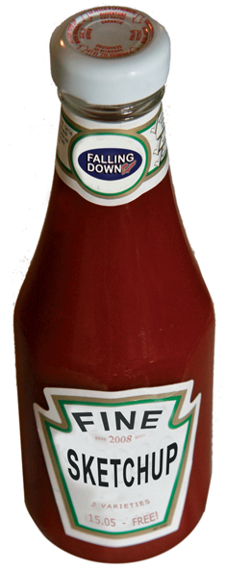
Falling Down With Laughter (Best Small London Venue 2008 - Chortle Awards) presents a daily showcase of the best sketch acts on the comedy circuit, from the hugely successful fortnightly show The Falling Down With Laughter Experiment.

Fine Sketchup features visiting acts, the latest up-and-coming sketch troupes and 2008 Fringe acts performing side projects, classic sketches, or new material.

There will be 3 different acts each day, performing 15-20 minutes each, including:

Pappy’s Fun Club if.comeddie nominees 2007
Fat Tongue if.comeddie nominees 2006
The Penny Dreadfuls ***** UK Theatre Network
The Gently Progressive Behemoth “Brilliant!” - Daniel Kitson
Idiots Of Ants ***** Edinburgh Festivals magazine
The Ugly Kid ***** Chortle
Two Episodes Of MASH Award-winning Joe Wilkinson & Diane Morgan
The Congress Of Oddities “Surreal deconstructionist brilliance” - Chortle
Cat Of The Week “Highly enjoyable” - Time Out
The Sunday Defensive “A terrific duo” – Time Out
Tea and Cake “Ones to watch in 2008” - The Scotsman
Dmitri and Vassily ***** Chortle
The Boom Jennies “Comedy genius!” **** Scotsgay
And more…

Line-ups at www.myspace.com/finesketchup

For more info contact Alexis Dubus:
07989 988 485 or alexis@alexisdubus.com
