MEDIA RELEASE

Who Lives? Who Dies? You Decide, M’Lord!
The interactive comedy game show returns to the Fringe for its third year,
with new guest royals, new kingdom troubles, and the exact same chaos

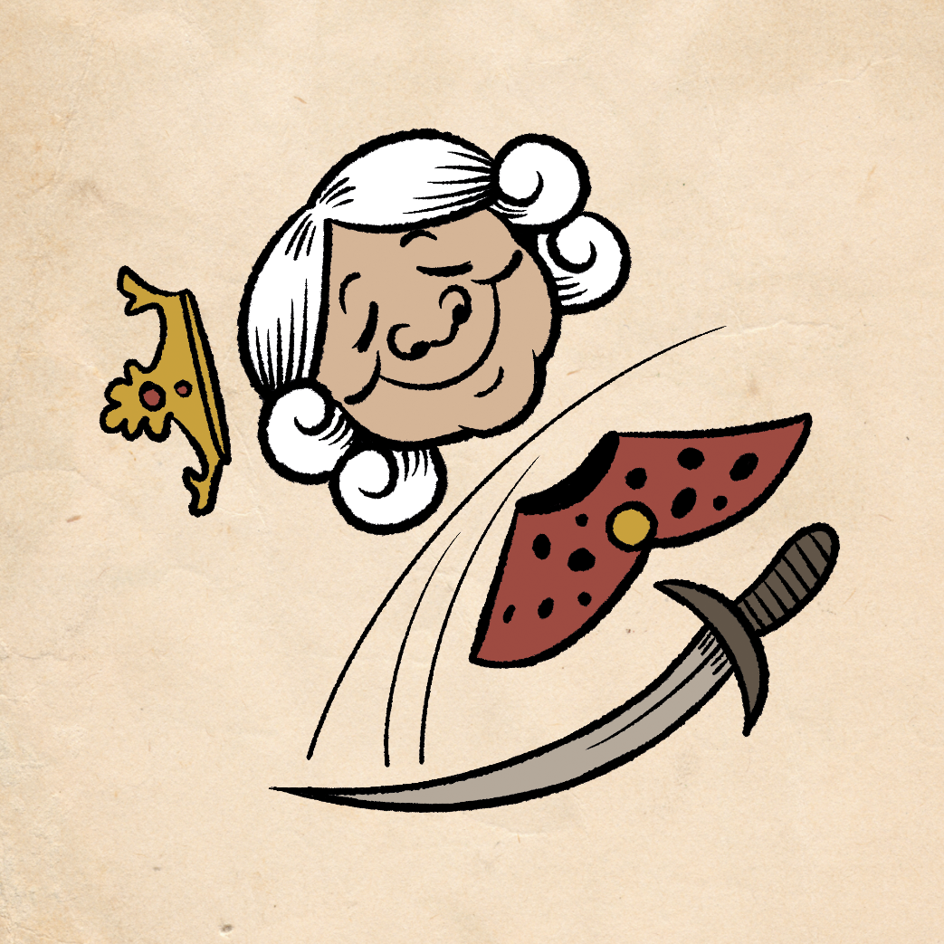

Off With Your Head!

19th May 2026, Edinburgh – Off With Your Head makes its return to the Edinburgh Festival Fringe for its third year, a show that boasts the most hilarious regicides in the Middle Ages. The show brings audiences into the 12th Century throne room of a cursed Kingdom. Guest performers will try their hand at ruling the kingdom, but the audience (Or as the show calls them, peasants) will have the final say on how long their reign will last.

PITCH LINE

The lines between genres begin to blur increasingly as we enter the second half of the 2020s, which makes it the perfect time for a show like Off With Your Head. Trying to describe what exactly the show is: An impossible task. How does one do an elevator pitch for a show that blends short-form improv with micro storytelling while being helmed by a stand-up comedian? What about the interactive and randomized mechanics designed by TTRPG and video game developers? Can you even succinctly explain the atmosphere of an entire audience that willingly jumps into some sort of demented panto, turning them into both viewer and performer?

That is Off With Your Head, a show where there are no clear lines between planned and improvised, passive watcher and active player, beloved ruler and malevolent dictator. Helmed by host Sam See and co-host Stephen Case (Billed as the Royal Advisor and Jester Boy accordingly), the two are also the show’s creators. Audiences are brought into the world of a 12th Century medieval kingdom, cursed with unstable leadership as no ruler has lasted on the throne for more than twelve months, dying before the year is up through incredible circumstances. Guest players from the realms of comedy, theatre, the Internet, and television have a go at the top job in the realm, solving the kingdom’s problem, and trying to break the curse. At the end of the day though, the audience have all the power, not just by playing various members of the kingdom to help or hinder the guests, but by also voicing loudly if they are pleased or enraged with the ruler, which in turn may (And often does) lead to their demise.

Although only in its third year and second full run season, the show has already gone from strength to strength. It has been invited for the second year in a row to the UK Games Expo, the largest board game convention in the United Kingdom, and has already expanded its performance sphere out of Edinburgh and London to now include Brighton and Singapore. Previous guest have included notable names like Jenny Ryan (The Chase), Jenny Tian (Taskmaster Australia), Ray O’Leary (Taskmaster New Zealand), Becca Scott (Dropout, Good Time Society), Chris Grace (Superstore, Dropout), Dom Allen (No Rolls Barred), and Mike Mason (Designer of Call of Cthulhu), to name just a few of the former guests who have graced the show.

We would love to invite you to a performance of the show. We would also love to talk more with you about Off With Your Head, the process behind creating and performing a show of this unique nature, and creating a space where nerds, geeks, jocks, or just ‘regular people’ can all unite under the power of comedic schadenfreude.

SHOW DETAILS

Off With Your Head will be performed daily (Sans Tuesdays) at 20:15hrs/8:15pm from August 6th (Thursday) till August 31st (Sunday) at West Nic Records (FKA 32 Below), in the Main Cellar room. The show is part of the Laughing Horse’s Free Edinburgh Fringe Festival, and a joint production of Bowtie Productions and RGB Monster. As this show is part of the Free Fringe Festival, please contact us below for all ticket reservations.

Off With Your Head is developed by comedian Sam See and game designer Stephen Case. The show is also hosted by Sam See as the ‘Royal Advisor’, with co-host duties during the Fringe fluctuating between Stephen Case and comedian Joe Mayo as the ‘Jester Boy’.

Our press kit can be accessed here via Google Drive.

Off With Your Head!
Dates: August 6th – August 31st 2026 (No Tuesdays), 8:15pm
Location: West Nic Records, 32b W Nicolson St, Newington, Edinburgh EH8 9DD, United Kingdom
Duration: 55 mins
Rating: 18+ (Restriction due to venue laws)
Show Listing on EdFringe.com: https://tickets.edfringe.com/whats-on/off-with-your-head

For more information about the show and the developers, or to arrange for media enquiries,
you may contact:
Samuel See | contact@bowtieproductions.com | +44 07449 299708

