MEDIA RELEASE

The Best Asian Comedians at The Fringe (and One Token White one)!
The showcase with the funniest Asian comedians from all over the World and the UK

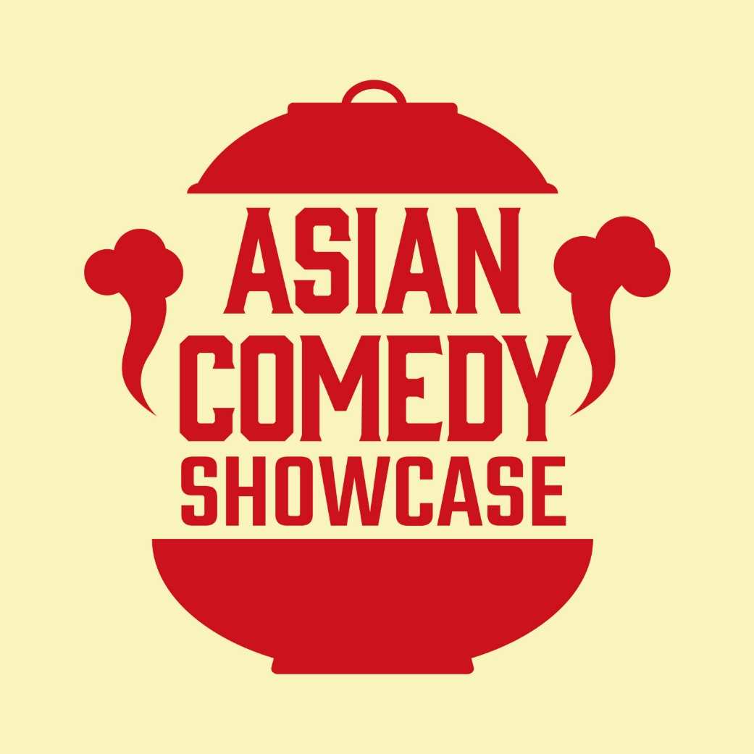

The Asian Comedy Showcase

18th May 2026, Edinburgh – The Asian Comedy Showcase returns the Edinburgh Festival Fringe for its fourth year, bring more of the best Asian comedians on the Fringe, and the best Token White acts.

PITCH LINE
It is not often one sees an Asian comedian on a show in the UK, whether it be their own solo show or even a showcase. Even when they do get booked, they get labelled behind the scenes as the ‘token Asian act’, the minority booking for the night, and because of this rarely work with any other Asian comedians as most shows have the arbitrary rule of one only.

In response to the lack of work, and the lack of a chance to share the stage with fellow Asian comedians, the Asian Comedy Showcase was created in 2023 at the Edinburgh Festival Fringe. Although the concept of an all-Asian lineup has been proposed and produced in the past, it was the first showcase that had an ethos to represent all Asian, not just a focus on certain parts of the continent, like South or East Asia. Since then, the Showcase has welcomed over 80 different Asian comedians from all over the world, from acts performing stand-up for the first time ever, to established names of stage and screen like Eshaan Akbar (QI, Mock The Week), Jenny Tian (Taskmaster Australia), Li Jin Hao (Unnamed Judd Apatow Comedy), Urooj Ashfaq (Best Newcomer - Edinburgh Comedy Awards), Kavin Jay (Netflix), and many more.

One of the showcase’s unique selling points is the inclusion of the Token White act, inspired by the Alternative Black Comedy Showcase. Every show will include one, but the showcase has also made an effort outside of the joke to work with acts whom have also dealt with exclusion in their careers. Former Token White acts include Ed Byrne (Mock the Week, QI), Soness Stevens (Sanrio’s Hello Kitty), Grubby Little Mitts (Best Debut Sketch Show – Amused Moose), Robyn Reynolds (Best Newcomer Nomination – Melbourne International Comedy Festival), and more.

Now in its 4th year, its creator and host Sam See is excited to bring more new Asian comics to the showcase. Some new names include Lizzy Hoo (Amazone Prime), Noah Szto (Best Newcomer – Melbourne International Comedy Festival), and Phil Wang (Taskmaster, Great British Menu), along with up-and-coming names from the Uk and Edinburgh comedy scene. The showcase plans to have its biggest year to date, with not just the best acts available, but the best acts, bar none.

We would love to invite you to watch one of the shows. We would also love to talk with you more about the showcase, the drive to find acts and to ensure all acts are paid for their work, and creating a space for people from all backgrounds, whether it be Asian or otherwise, to enjoy and realize the potential of Asian performers.
SHOW DETAILS

The Asian Comedy Showcase will be performed daily (Sans Tuesdays) at 13:00hrs/1:00pm, from August 6th (Thursday) till August 31st (Sunday) at The Pear Tree. The show is part of the Laughing Horse’s Free Edinburgh Fringe Festival, and produced by Bowtie Productions. As this show is part of the Free Fringe Festival, please contact us below for all ticket reservations.

The Asian Comedy Showcase was created and is regularly hosted by Sam See, a Singaporean comedian and host currently based in the UK.

Our press kit can be accessed here via Google Drive

The Asian Comedy Showcase
Dates: August 6th – August 31st 2026 (No Tuesdays), 1:00pm
Location: The Pear Tree, 36 W Nicolson St, Newington, Edinburgh EH8 9DD, United Kingdom
Duration: 55 mins
Rating: 16+ (Guideline)
Show Listing on EdFringe.com: https://www.edfringe.com/tickets/whats-on/the-asian-comedy-showcase

For more information, or to arrange for media enquiries, contact:
Samuel See | contact@bowtieproductions.com | +44 07449 299708

