MEDIA RELEASE

Arrested by his Government for jokes,
he survived it all, and he can’t stop joking about it
Rizal van Geyzel (MLY) takes you on his journey through Malaysia and his experience being arrested and having his world turned upside down… all because of a joke

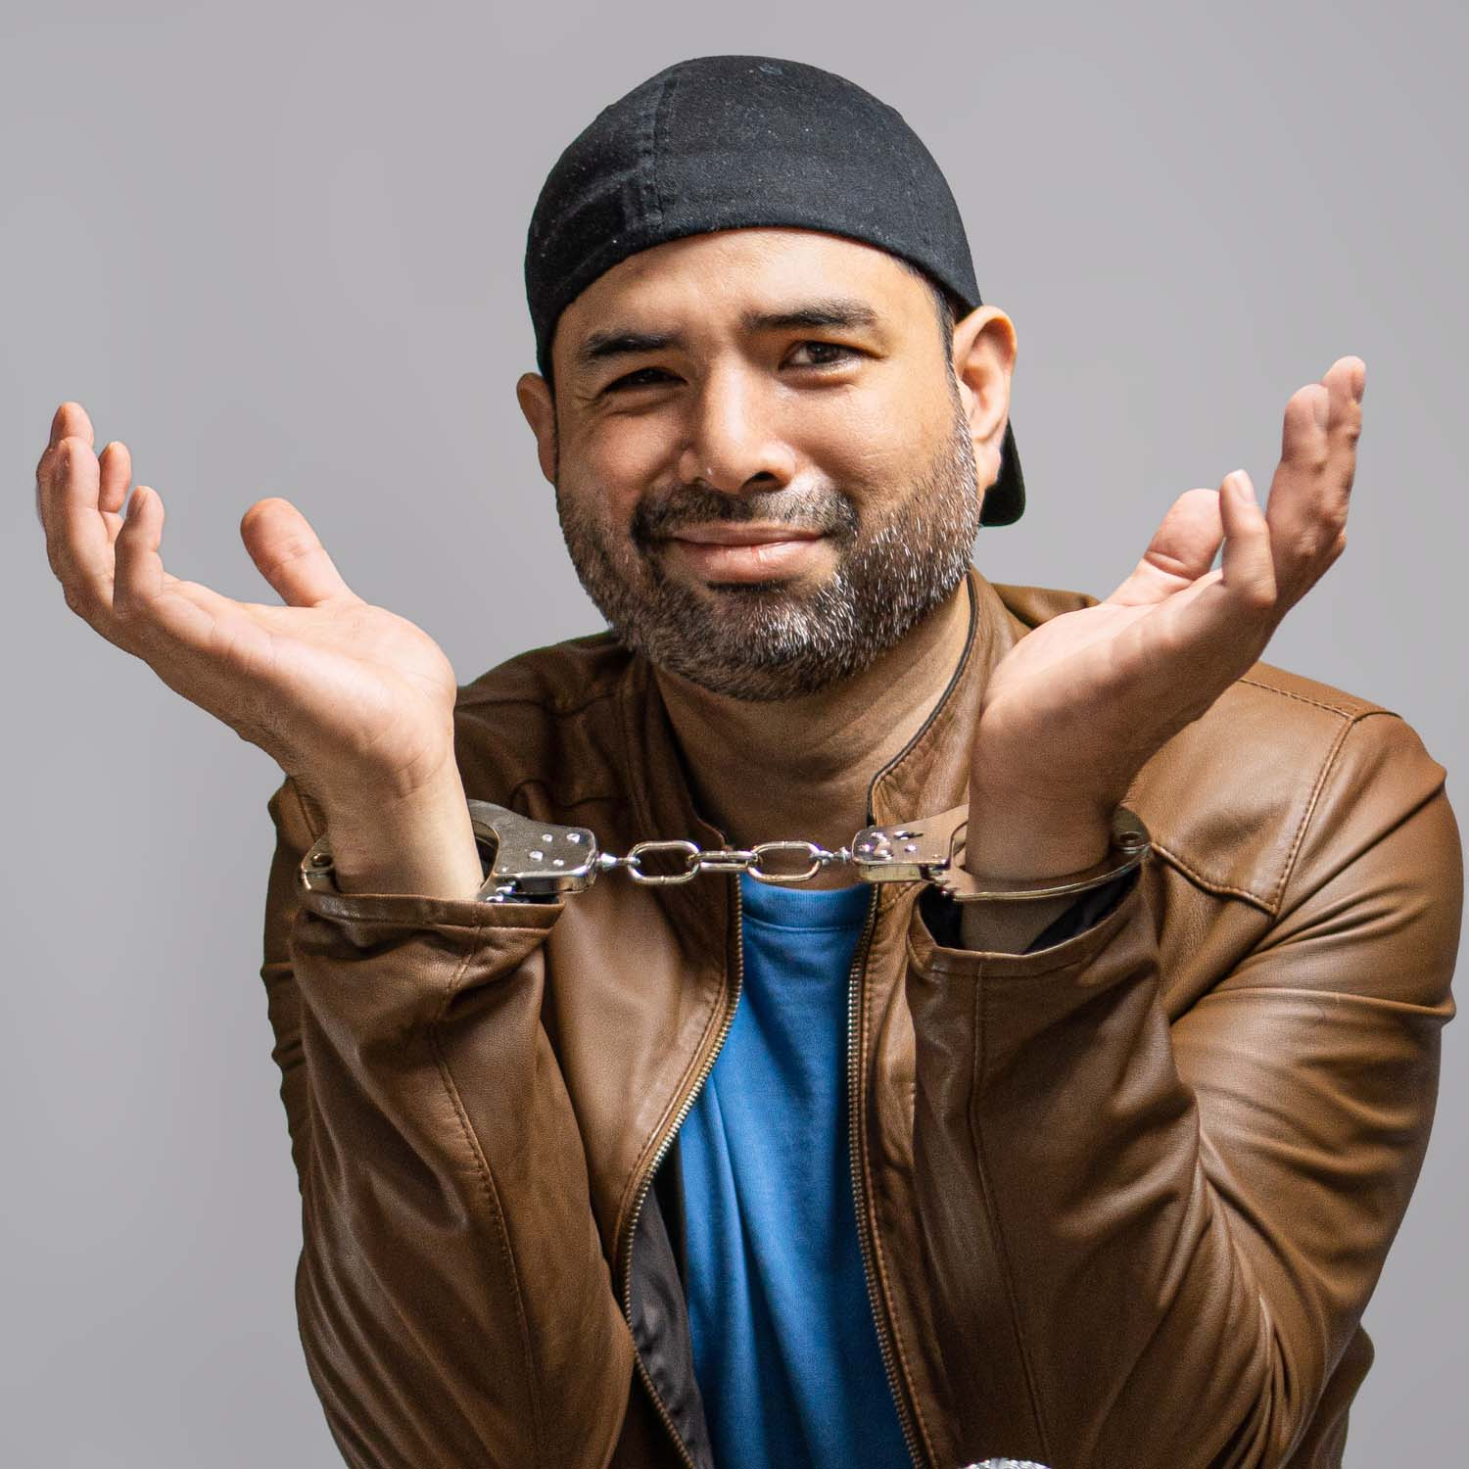

Rizal van Geyzel: Arrested

18th May 2026, Edinburgh – Rizal van Geyzel return to the Edinburgh Festival Fringe in 2026, with his stand-up comedy show Arrested, which covers his time as a comedian and comedy club owner in Kuala Lumpur, Malaysia, his arrest by the Royal Malaysian Police, and how he came out the other side of it still laughing.

PITCH LINE
In our current cultural climate of online figures stoking the flames on ‘speaking your truths’ and ‘getting cancelled’, Rizal van Geyzel has done both, and in a realm where none of them would dare to thread. As a comedian and a Malay Muslim man, van Geyzel’s career had always focused on being one of the top performers in Malaysia, running a comedy club to bring stand-up comedy to both expats and his own people. All was going well, till an incident caused him to get arrested for making jokes about his own Islamic heritage. What followed was a year under fire from right-wing extremists, a hostile government, and a sedition hearing that could have ended it all for him.

After surviving imprisonment, online slander, and a malevolent bureaucratic system, van Geyzel made it out but very much scathed. Instead of running or hiding like most have, he decided to do what he does best: make laughs and talk about these harrowing experiences like only he can. His show will take you inside the incident and subsequent arrest, his night in a Malaysian prison cell, and his surreal journey through their justice system. Along the way, he uncovers uncomfortable truths that he learned the hard way about the Left vs the Right, the online ‘mob’, and what power they actually wield in person.

Van Geyzel still believes that comedy can unite people, a belief that has earned him hatred instead of applause in his home country, but he knows that Arrested is a show to do just that at the Edinburgh Festival Fringe this year.

We would love to invite you to the show and talk to you more about Rizal van Geyzel: Arrested, the additional stories and feelings that cannot be fully conveyed in this fifty-five minute show, and how important it is to speak truth with the consequences that many do not truly understand or have faced.

SHOW DETAILS
Rizal van Geyzel: Arrested will be performed daily (Sans 17th August, Monday) at 15:15hrs/3:15pm, from August 6th (Thursday) till August 30th (Sunday) at The Counting House, in the Loft room. The show is part of the Laughing Horse’s Free Edinburgh Fringe Festival, and a production of Bowtie Productions. As this show is part of the Free Fringe Festival, please contact us below for all ticket reservations.

Rizal van Geyzel: Arrested has been written and performed by Rizal van Geyzel, born and based in Malaysia.

Rizal van Geyzel: Arrested
Dates: August 6th – August 25th 2025 (Except 17th Aug), 3:15pm
Location: The Counting House, The Loft (34 W Nicolson St, Newington, Edinburgh EH8 9DD)
Duration: 55 mins
Rating: 18+ (Restriction due to venue laws)
Show Listing on EdFringe.com: https://www.edfringe.com/tickets/whats-on/rizal-van-geyzel-arrested

For more information about the show and to arrange media tickets and enquiries:
Samuel See | contact@bowtieprodctions.com | +44 07449 299708

