MEDIA RELEASE

Released from prison, he now serves the hardest labour of all:
Being a single father
Rizal van Geyzel (MLY) goes from the big house to wearing the big pants in the family, taking care of three kids as a single parent while dealing with addiction

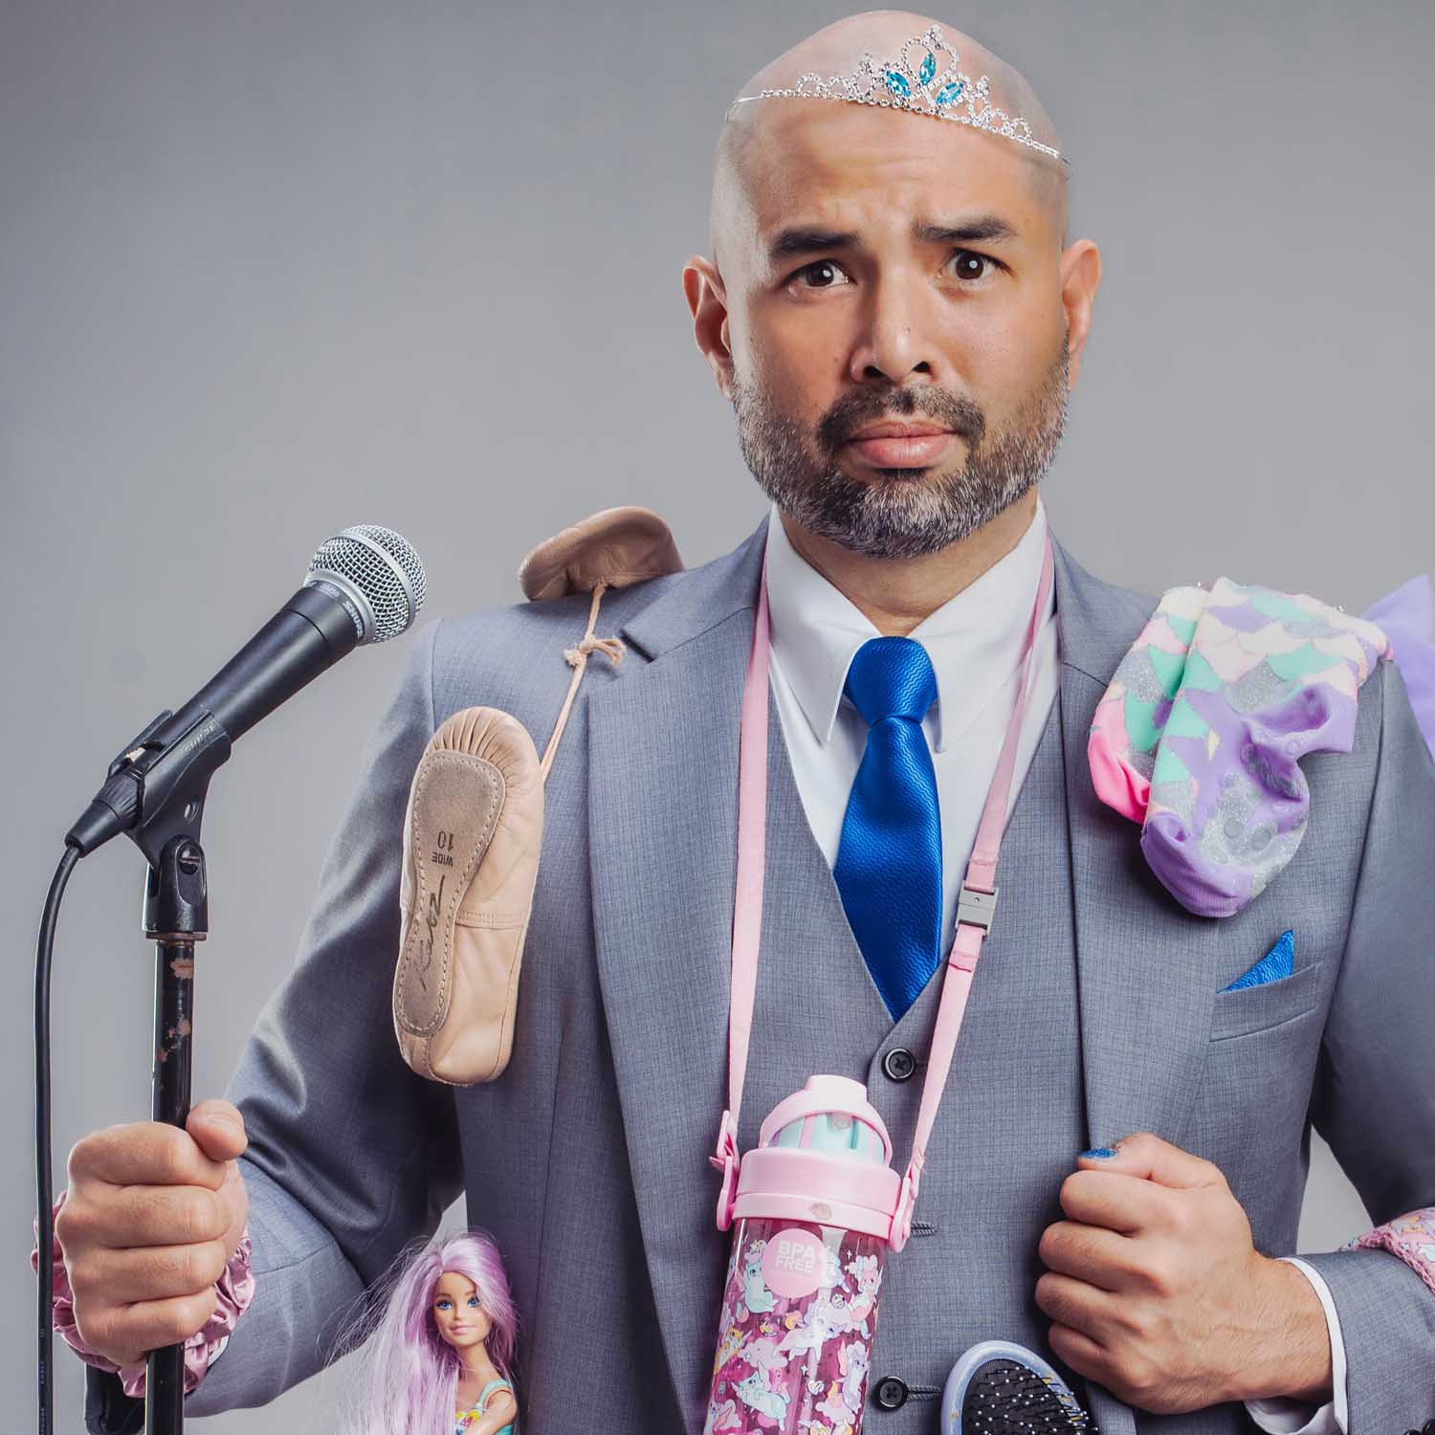

Rizal van Geyzel: Single Fatherhood

18th May 2026, Edinburgh – Rizal van Geyzel return to the Edinburgh Festival Fringe in 2026 with his new stand-up comedy show Single Fatherhood, which directly follows the events of his previous hour show Arrested. Van Geyzel’s new show covers the hardship of leaving prison and going straight into taking care of three children freshly after a divorce. He now must take care of them, while dealing with his own addiction, and his show finds him seeking the hardest virtue of adulthood: accountability.
PITCH LINE
After losing his comedy club, his credibility due to a malevolent government, and his wife, Rizal van Geyzel did gain something: Three children to take care of. After gaining custody through the divorce proceedings, van Geyzel had to tackle their care as a single parent, while trying to deal with the fallout of a politically motivation persecution against him by the State.

As if that was not enough, van Geyzel’s desire to gain custody was to rescue the children from his ex-wife’s substance addiction, the same substance addiction that he now has to deal with in himself. This torrential downpour of unfortunate events is nothing new in the life of a stand-up comedian in a country as turbulent as Malaysia. However, now van Geyzel must step up not just for himself and his career, but for his new wards. Can he set a good example from the children, while saving himself from the same addictions that plagued him and his former wife?

Single Fatherhood is a show about survival, chaos, and trying not to fall apart while van Geyzel lays his life bare, showing how bad choices turn into good ones when the kids are watching. Van Geyzel’s show also tackles the virtue of accountability for one’s life choices, which he believes that life happens for you, not to you. Van Geyzel hopes to show through one of his best stand-up comedy hours that through the pain and the discomfort, whether you can see it or feel it, that there is always growth.

We would love to invite you to the show and talk to you more about Rizal van Geyzel: Single Fatherhood, the additional stories and feelings that cannot be fully conveyed in this fifty-five minute show, and how important it is to find the strength, even when the World finds new ways to test your resolve.

SHOW DETAILS
Rizal van Geyzel: Single Fatherhood will be performed daily (Sans 17th August, Monday) at 18:00hrs/6:00pm, from August 6th (Thursday) till August 30th (Sunday) at The Counting House, in the Attic room. The show is part of the Laughing Horse’s Free Edinburgh Fringe Festival, and a production of Bowtie Productions. As this show is part of the Free Fringe Festival, please contact us below for all ticket reservations.

Rizal van Geyzel: Single Fatherhood has been written and performed by Rizal van Geyzel, born and based in Malaysia.

Rizal van Geyzel: Single Fatherhood
Dates: August 6th – August 25th 2025 (Except 17th Aug), 6:00pm
Location: The Counting House, The Attic (34 W Nicolson St, Newington, Edinburgh EH8 9DD)
Duration: 55 mins
Rating: 18+ (Restriction due to venue laws)
Show Listing on EdFringe.com: https://www.edfringe.com/tickets/whats-on/rizal-van-geyzel-single-fatherhood

For more information about the show and to arrange media tickets and enquiries:
Samuel See | contact@bowtieprodctions.com | +44 07449 299708

