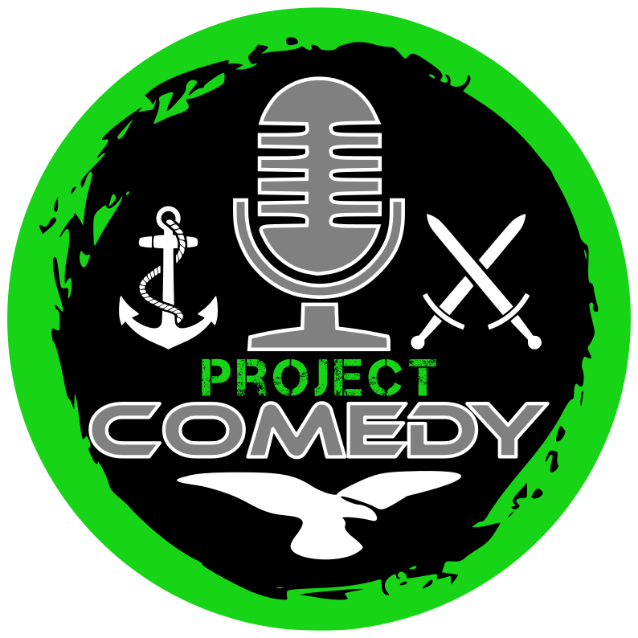 | info@projectcomedy.co.uk  www.projectcomedy.co.uk  Lead Ambassador - Jay Saunders  07586 429355  Ambassador - Nick Cheng  07536 136490  FOR IMMEDIATE RELEASE

Laughing Through the Pain: Veterans Turn Trauma into Comedy Gold

Who would have thought that you can laugh at wounded veterans to aid their recovery?
Given the number of threats we have faced worldwide for multiple decades, it's unsurprising that we have a significant number of service personnel being medically discharged with life-changing wounds. Most of these injured veterans spend the remainder of their life in some form of recovery.
Enter Project COMEDY with a unique way these veterans can gain recovery - by getting laughed at!
Established during the 2020 covid lockdowns, Project COMEDY trains veterans in the art of stand-up comedy so that its beneficiaries can find wellbeing, transferable skills and recovery.
Lead Ambassador Jay Saunders explains: “Veterans find it near impossible to accept compliments and praise. But when somebody laughs at one of your jokes, it feels like you're being thanked for giving them a tiny gift.”
The military is infamous for dark humour that many civilian comedians have aped. Jimmy Carr once got into trouble with the joke: "Say what you like about those servicemen amputees from Iraq and Afghanistan, but we're going to have a f****** good Paralympic team in 2012.” The majority of veterans didn't have a problem with this gag as their sense of humour is even darker.
Through the art of stand-up comedy, the beneficiaries of Project COMEDY are able to turn their dark moments into outstanding comedy that entertains civilian audiences. Yet they've gained the skills to enable audiences to leave their shows feeling uplifted rather than shocked.
And a brave collection of these veterans are inviting you to laugh at them this summer. Project COMEDY is presenting two shows at the Edinburgh Festival Fringe. A fun competition called ‘Should Have Tried Harder at School - Veterans v Civilians’ and their showcase performance ‘Gags Army’.
Every penny raised at the Edinburgh Festival Fringe will be reinvested into Project COMEDY to enable more veterans to find this remarkable form of recovery through humour and its parent charity Project RECCE.
Former soldier and comedian on rise Jim Bob states: “The thrill, the feeling when you hit the punchline and the audience laugh, it’s like nothing I've ever felt before. What a rush! I feel alive again!”
Both shows are presented as Pay What You Can performances, but seats can be reserved for reviewers by emailing Project COMEDY (email address at the top of this media release).

General public tickets can be purchased at:
Should Have Tried Harder at School – Veterans v Civilians
https://www.edfringe.com/tickets/whats-on/should-have-tried-harder-at-school-veterans-v-civilians
Gags Army
https://www.edfringe.com/tickets/whats-on/gags-army
Help show our veterans that their voices — and their laughter — still matter.

