**MICHELLE AHERN: WE’VE HAD A GOOD RUN**

In 2022 Michelle was a wife and a step-mum living on the east coast of Australia. It’s the summer of 2024 and she is now a very single, stand-up comedian living alone in Spain. “WTF happened and why is someone trying to sue her?” is the tagline for Michelle’s debut solo show ‘*We’ve Had A Good Run’*: the one-hour comedic storytelling show that chronicles the past two years of Michelle’s life, starting with the life-changing discovery of her husband’s affair that lead her across the globe to Spain and into the arms of a life of comedy.

It’s a tale as old as time, trauma leads to creativity: Michelle’s story is no exception as she attributes comedy as the life raft that saved her. ‘I knew I had to start fucking paddling.’

Although she had never performed any sort of comedy at this point, Michelle was no stranger to writing (having written poetry, short stories and essays all her life) and so she started to put pen to paper on the story of the circumstances unfolding around her.

As she set off from the shores of Australia in August 2022, on what was meant to be a six-week trip to Europe, Michelle quickly found herself in Spain in a world of wild sex-ploration, sangria and something about soup?! Becoming more and more adamant about wanting to tell her story and starting to have her sights set on the famous Edinburgh Fringe Festival, she knew she had a lot to learn about comedy and storytelling and so she joined a five-day standup comedy course taught by creative director Dec Munro of the Angel Comedy Club. And here the comedy journey began.

*We’ve Had A Good Run* is the culmination of 18 months of stand-up, sketching, clowning, crying, writing, watching and laughing. The one-hour solo show is a rollercoaster of feels, told with a raw authentic voice, a little bit of dance and sometimes, sock puppets. Michelle’s unique energy, quick wit and charm generate a warmth with the audiences she so clearly appreciates and it’s hard to walk away from the show not having felt a little something.

*We’ve Had A Good Run* is on at The Den@Eastside as part of the Free Fringe with Laughing Horse.

12-25 August, 3.20pm. You can check out how Michelle’s journey started in the documentary ‘[*Laughing Matters*](https://www.youtube.com/watch?v=sRuXnwCakws)’ filmed at the Angel comedy Club in 2022, directed by Jamie Perault for The National Film & Television School, London.

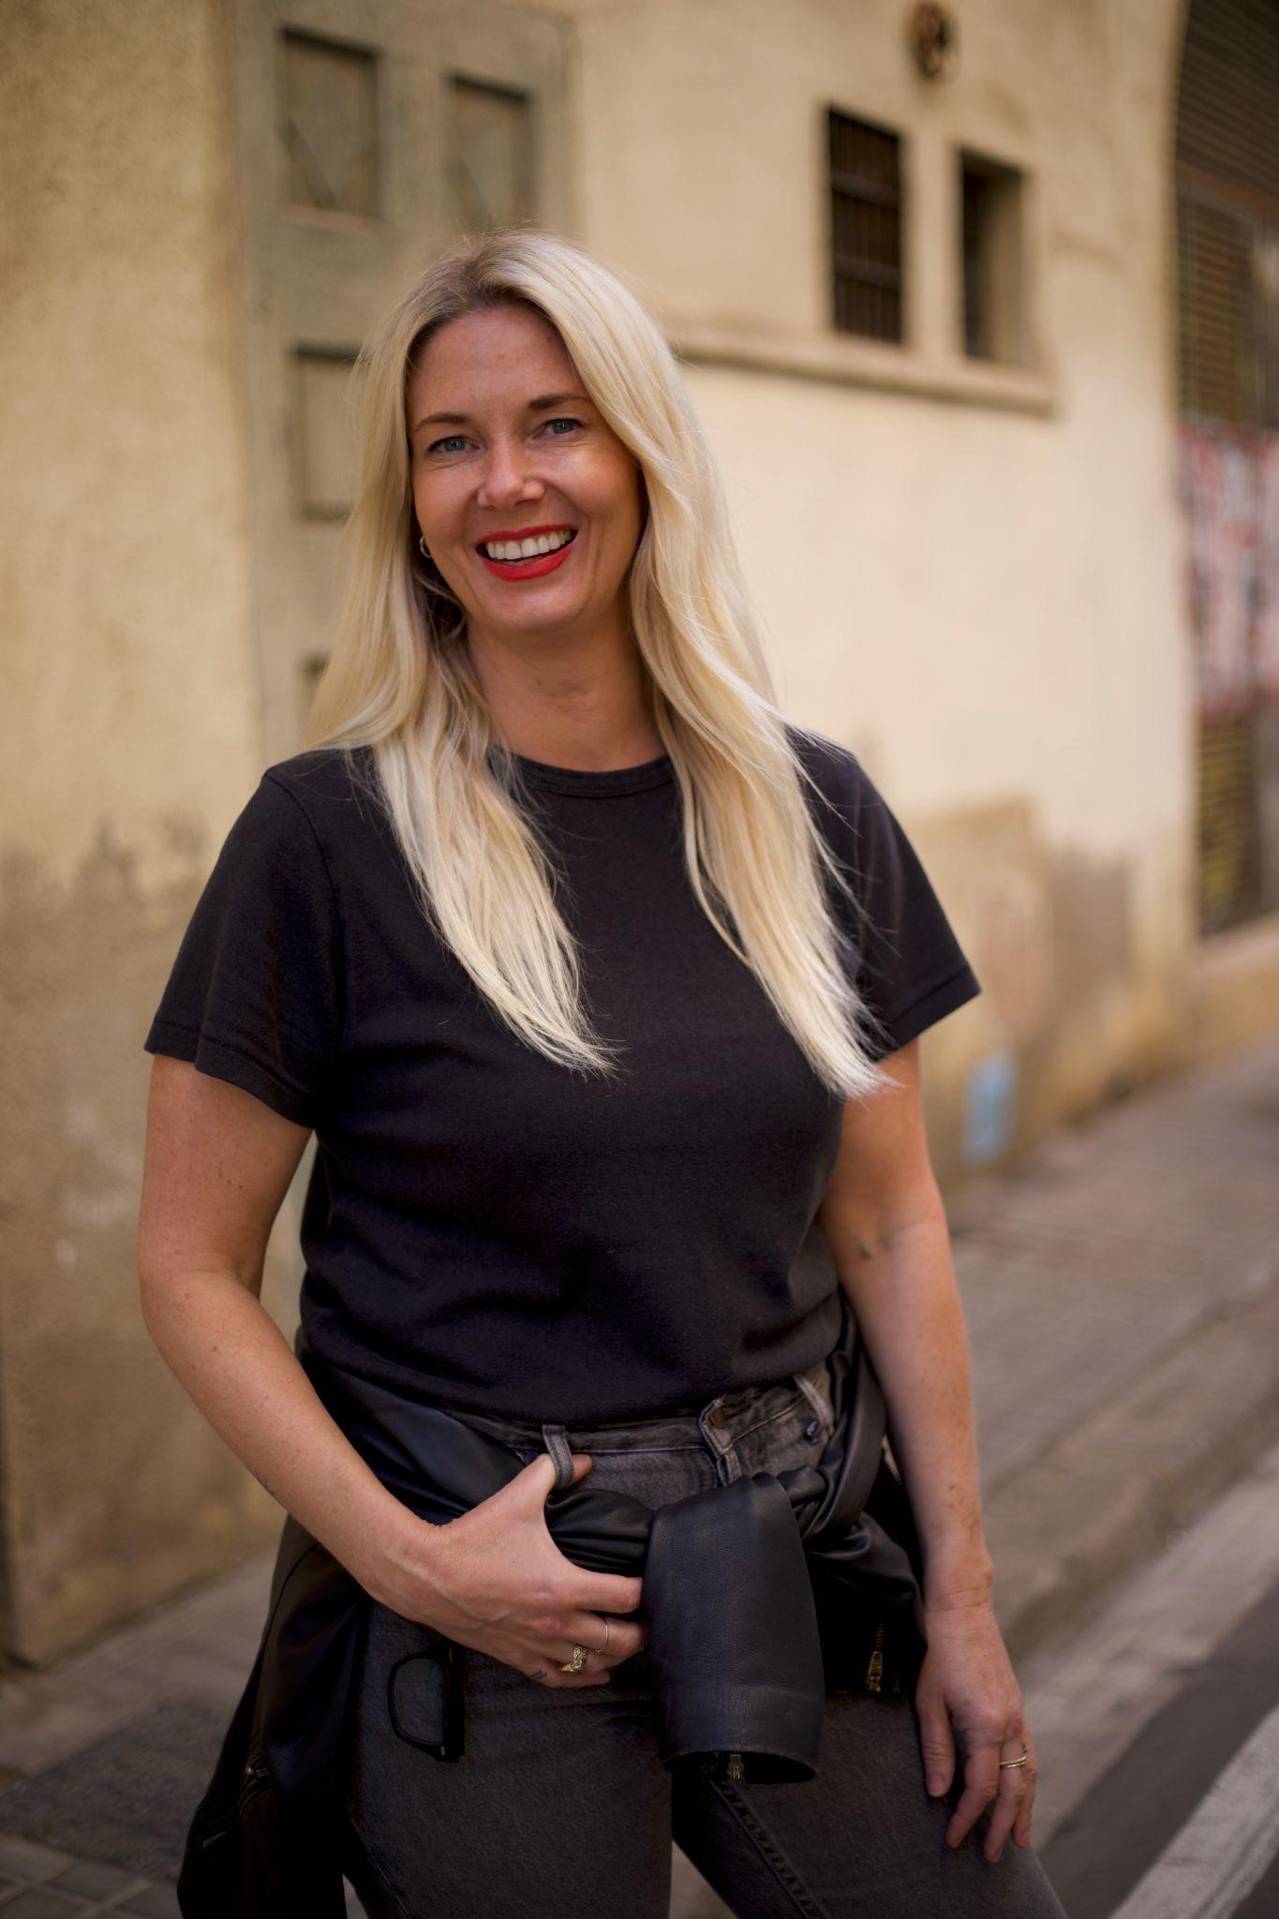

**BIOGRAPHY: MICHELLE AHERN**

Michelle Ahern is an Australian comedian and writer living and working in Barcelona, Spain. She started her comedy career in 2022 and since then has performed in over 250 shows of standup, sketch and improv in the UK, Australia, Ireland and Spain. From performing at the Opera House in Cork, Ireland to hosting one of the wildest open-mic comedy shows in Barcelona, Michelle might be a new face to the world of comedy but her quick wit and raw and honest storytelling has quickly established her as an integral part of the English-speaking comedy scene in Europe. Michelle has completed formal training in standup comedy and clowning in London, UK. In 2024 she will be taking her debut solo show, *We’ve Had A Good Run* to the Edinburgh Fringe. Michelle’s story has been featured in the documentary ‘[*Laughing Matters*](https://www.youtube.com/watch?v=sRuXnwCakws)’ filmed at the Angel comedy Club in 2022. Directed by Jamie Perault for The National Film & Television School, London



**LISTING DETAILS**

**Date & Time:** August 12-25 3:20pm

**Venue:** The Den@ Eastside, Laughing Horse, 51a George St, Edinburgh EH2 2HT

[**Tickets**](https://tickets.edfringe.com/whats-on/michelle-ahern-we-ve-had-a-good-run)**:** Pay What You Want. Advanced reservations from £2.50

**Media Contact:** Michelle Ahern [michelle@agentblonde.com](mailto:michelle@agentblonde.com) +34673299005

**Instagram:** @michelleaherncomedy

**AUDIENCE FEEDBACK 2024**

“We laughed. We cried”

“Powerful first ever hour from Michelle”

“Brave. Hilarious. Inspiring. Heartbreaking”

“Absolute rollercoaster”

“I’m never getting married after that!”

**OTHER MEDIA**

Documentary: [Laughing Matters](https://www.youtube.com/watch?v=sRuXnwCakws) Directed by Jamie Perault for The National Film & Television School, London

[European Comedy](https://europeancomedy.com/if-not-us-who-if-not-now-when-michelle-ahern-and-iain-anderson-talk-traumedy-by-kim-skinner/) article 17 July 2024