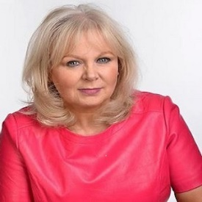

Martha McBrier: Who Knew?
PWYC/ Free Festival
Laughing Horse @Dragonfly – Main Room
16.30
Aug 4-7, 9-14, 16-21, 23-28 (not Mondays)

If you would like a seat reserved in order to review the show, please let us know on the contact details below.
Press contact:
marthamcbrier@gmail.com
Tel: 07979 625357

“Female comic genius”
Kate Copstick – the Scotsman
“A hoot”
Scotsgay
“A knack for funny storytelling”
Broadway Baby
“The hour appeared to flash by much too quickly”
one4review

'Naturally charismatic storyteller' (Fest) weaves a shocking but very funny account of her youth. Netflix documentary-worthy with a jaw-dropping twist. Comedy storytelling at its absolute best. Warning: May contain The Slosh. Award-winning and critically acclaimed writer and performer, McBrier brings a personal stand-up storytelling show about badness and kindness. We were 'that' family. Sometimes the apple not only falls far from the tree, but can take root somewhere else. 'Funny like Chic Murray was funny' ***** (Scotsman). 'A hoot from start to finish' ***** (ScotsGay.co.uk).
Martha McBrier has taken comedy storytelling to a new level. McBrier developed this skill after adapting to losing her hearing following a diagnosis of acoustic neuroma. McBrier has won The Moth London story slam an astonishing 5 times (3 this year!)
‘Who knew?’ will examine the working-class, West of Scotland 1970’s upbringing; Alcoholism, religion, criminal activity, the usual stuff. McBrier and her siblings survived, and lived to tell the tales. And very funny they are too!

McBrier has a sundry list of accolades to her name. Hers was the first Free Fringe show to get a review, when Kate Copstick fell for her charms back in 2007. She won the very first “So You Think You're Funny" competition at Glasgow’s May Fest. She’s the first deaf female comic. A Finalist for Funny Women, Laughing Horse and Nominee for the Malcolm Hardee Award. She is also a qualified Hypnotherapist, has been a counsellor for several years, worked in anger management and is a keen belly dancer.

y Baby

