Cynically Dead: A show to make you think: ‘Maybe I’m not doing so badly after all…’

Amsterdam-based comedians bring their new show to Brighton Fringe
@cynicallydeadshow

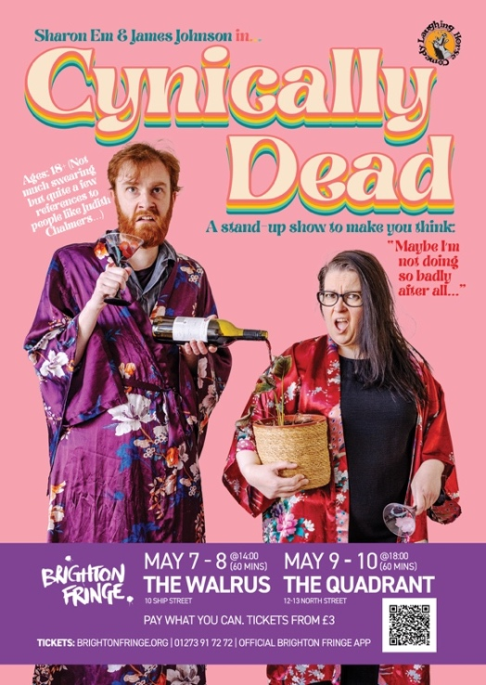
Ages 18 +
(Not much swearing but quite a few references to people like Judith Chalmers…)

Press Release: 3 May 2022

Sharon Em (IRL) and James Johnson (UK) have been wowing audiences on the international comedy circuit for years, performing in places as far afield as Luxembourg, Germany, the Netherlands and Japan. Now they’re bringing their split-bill show Cynically Dead to Brighton Fringe so UK audiences can finally see what all the fuss is about.

With both comics based in the Netherlands, the show is a chance for them to play for audiences who are more familiar with the high-brow concepts that appear in their stand-up: Richard & Judy, The Corrs and Wish You Were Here, that sort of thing. Funnily enough, despite all her globetrotting, no one outside Blighty has ever heard of Judith Chalmers….

Sharon Em fluctuates between trying hard and hardly trying. She meanders from place to place disproving the theory that ’not all who wander are lost’. She clearly takes on more than she can handle but always seems to find a way out.

James Johnson is a 30-something homosexual who would probably get on quite well with your nan, particularly if she has a penchant for gin. Described as ‘witty, eccentric and perfectly paced’, ‘gut-wrenchingly funny’ and ‘always a bit of a peculiar child’, he’s a quick-witted storyteller who minces at full throttle between the observational, the absurd and the ever so slightly dark.

Both have been described as ‘people who things just happen to…’ and Cynically Dead sees them each take a hilarious look at various aspects of their lives and wonder where it all went wrong. From disastrous treks across the desert to unwittingly spending 10 days on a SAGA cruise: if you’re looking for a show that makes you feel like you’re on top of things, they’ve got you covered.

It’s fast-paced, story-based comedy at its finest, with two of the most promising comedians the international scene has to offer. They’ve been honing their skills for years and are ready to show what they’re made of.

“Sharon is a joy to watch and on the best up and coming acts in Europe.” – Aiden Killian, Magners International Comedy Festival Asia

“James Johnson shows genuine promise as his personality shines and his take on the subject matter strikes an uncompromising balance between niche and accessible. His idiosyncratic punchlines and fast, perfectly pitched delivery put one in mind of Tom Allen, but the quality of Johnson’s writing needs to be acknowledged in its own right. Witty, eccentric and perfectly paced.” – Ed Fringe Review (2021)
Show dates
7 and 8 May – 14:00 – 15:00 The Walrus, Raised Room
9 and 10 May – 18:00 –19:00 The Quadrant, The Folklore Room
Pay What You Can. Tickets from £3.
www.brightonfringe.org/venues/sharon-em-james-johnson-cynically-dead-161619

Enquiries
James Johnson (jamesjohnsonproductions@outlook.com / +31 (0)6 51 88 51 17)

